The Position Property
The position property is used to orientate elements on the page. There are five elements associated with the position property; absolute, fixed, relative, sticky, and static.
Static
This is the default element. Block elements are stacked on top of each other, and inline elements are place beside each other in sequential order.
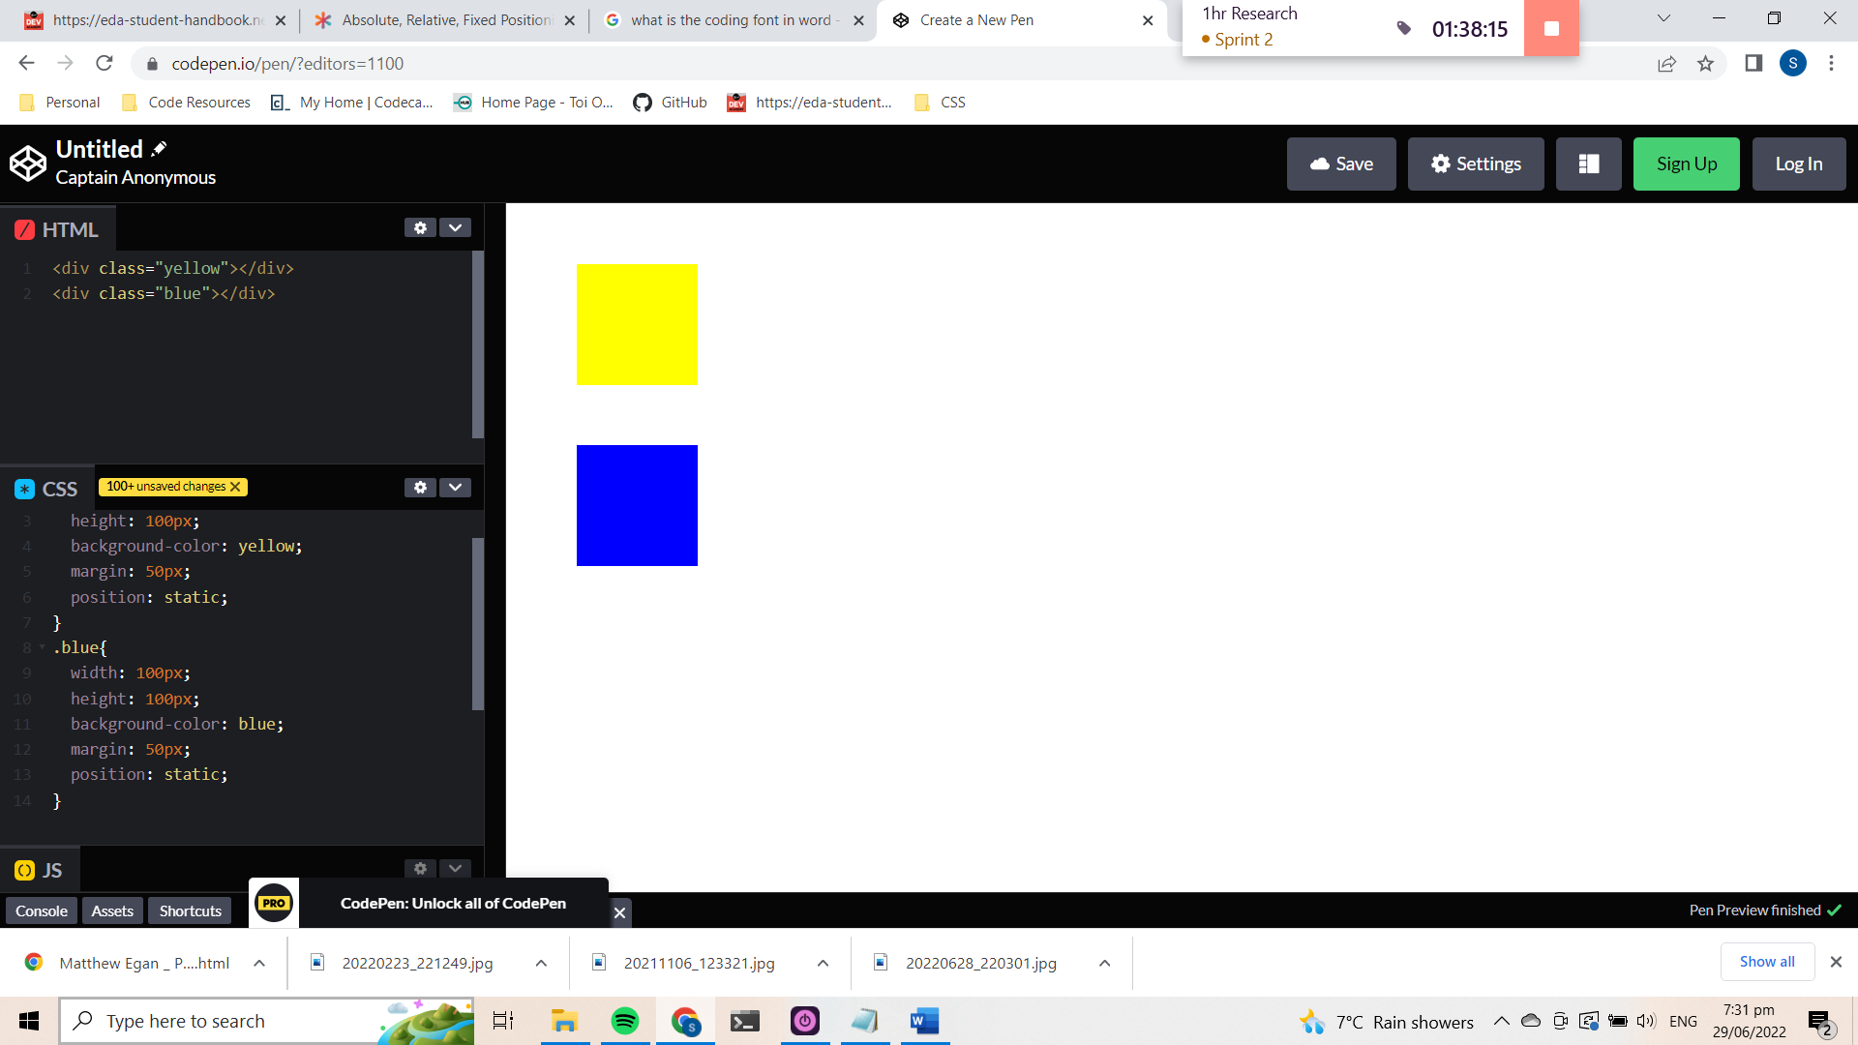
Static: The Two objects are stacked on top of each other.

Relative
This means “relative to itself” and will only have an effect if a related attribute is applied to it. The related attributes are; top, left, bottom, and right. Once the attribute is applied, the element will move in relation to its original (static) position on the page. This can be very valuable for tweaking the exact alignment of an element without having to consider the overall relativity of the page.

It works by adding the value to the given attribute direction. i.e. Setting a value to the left will cause the element to move to the right.
Relative positioned elements can however, move over top of statically positioned elements, so it is something to be aware of.

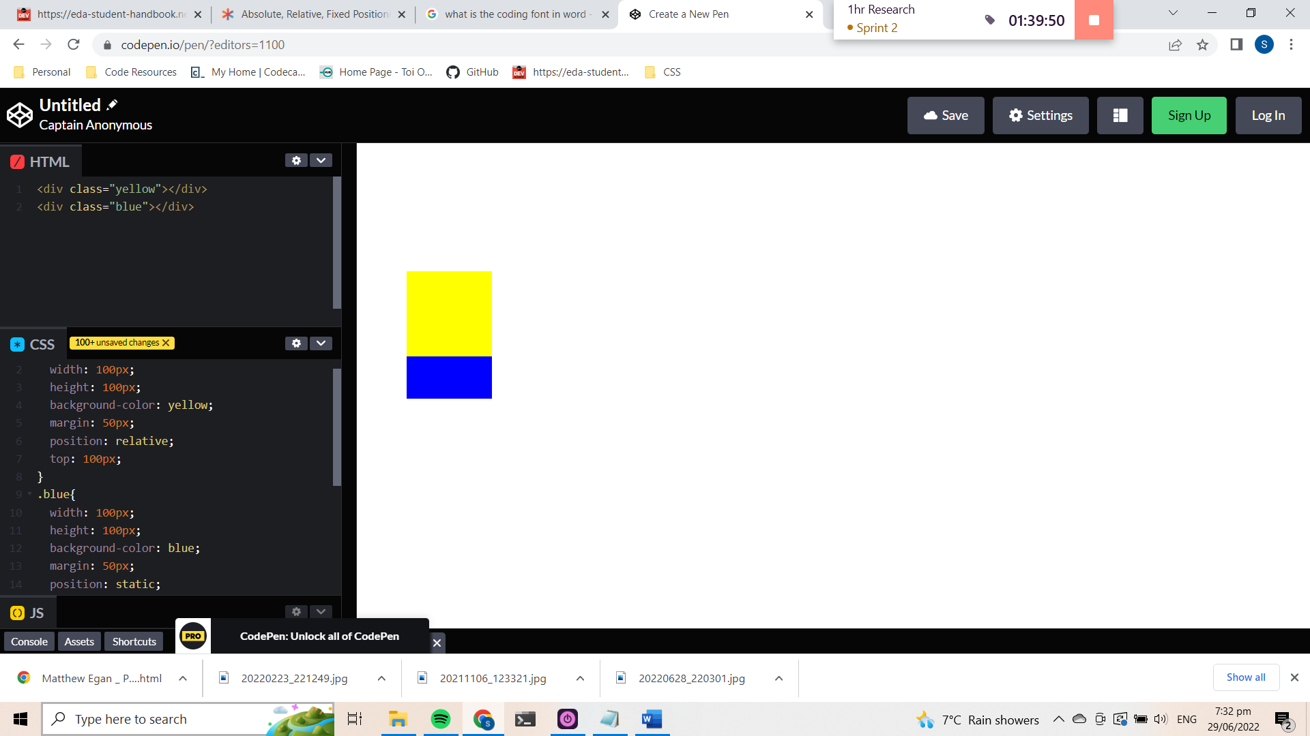
Relative: The blue object remains inline with the standard positioning. The yellow object has been moved down the page 100px relative to its default position on the page.

Absolute

Absolute positioned elements are relative to the next parent element that has relative or absolute positioning. If there aren’t any, they are relative to the to the html element. It also uses the positioning attributes top, bottom, left and right. Absolute positioning removes an element from being affected by document flow – the position of other elements on the page.

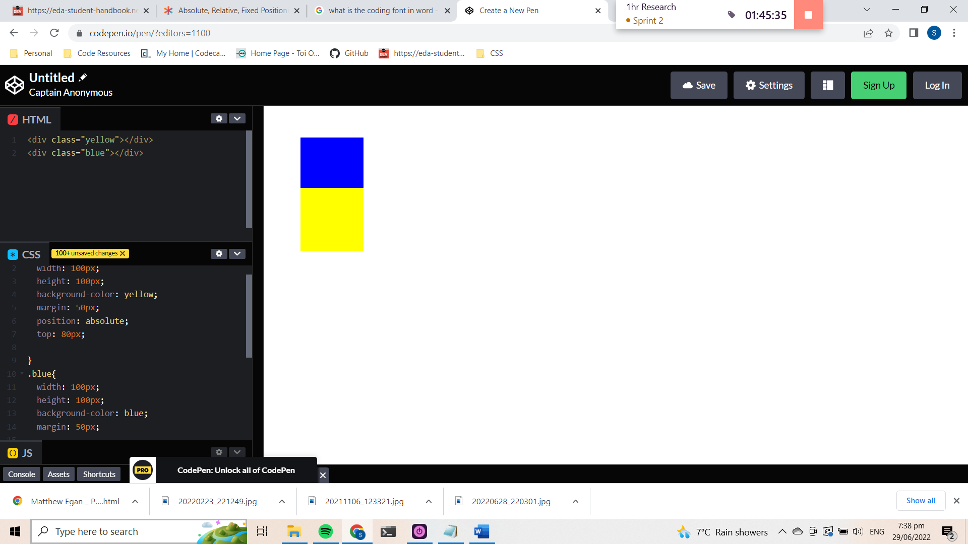
Absolute: The yellow object has been removed from the default positioning of the page. It is no longer affected by other objects on the page, nor are other objects affected by it. The yellow object moves 80px from the top of its parent element (with absolute positioning), in this case the html element. The blue object moves into the default static position as if the yellow object wasn’t there.

Fixed
An element with a fixed position stays in the same place relative to the viewport and sits overtop the other elements. This means even if you scroll across or down the page, the element will stay visible and fixed on the same position of the screen, while viewport moves over the rest of the document. An issue with this positioning, is that it is possible to cover up important areas of documents with the fixed element, so it is something to be aware of.
Sticky
An element with sticky positioning acts as a static element until it has been scrolled past, then it will act as a fixed element if the parent element has space.

https://css-tricks.com/absolute-relative-fixed-positioining-how-do-they-differ/
https://codecrunch.org/css-position-23ad6d0cc5f9

